Lifelong Learning Delegate Certificates

System URL: http://www.fasset.org.za/

- Enter Your User Name and Password
- Click on Login

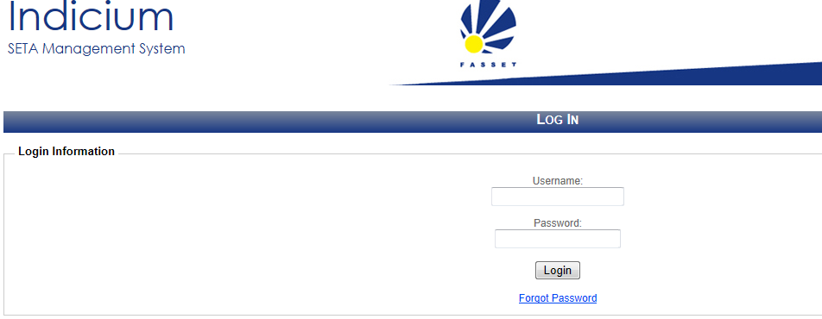

- Click on Skills

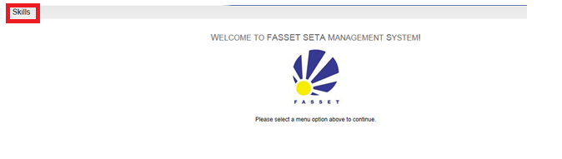
- Enter organisation information and click search

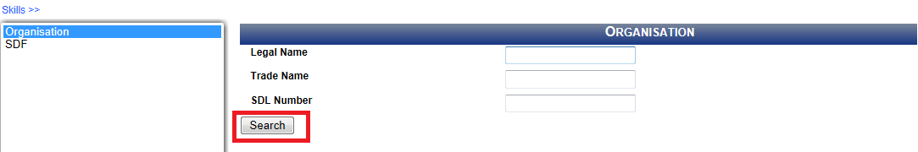

- Highlight the relevant company and click on the magnifying glass on the right.

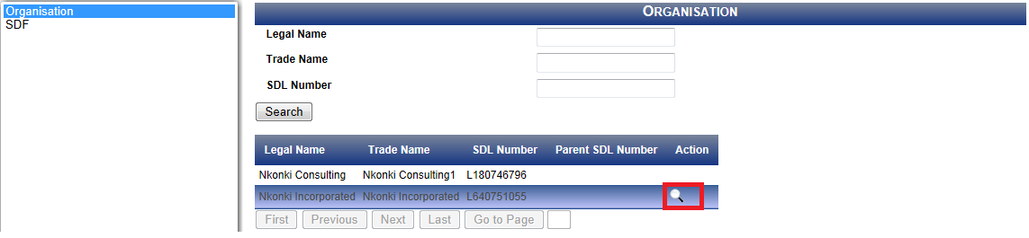

- Click on Delegate Certificate and enter the learners details or you can search and all the learners will be listed

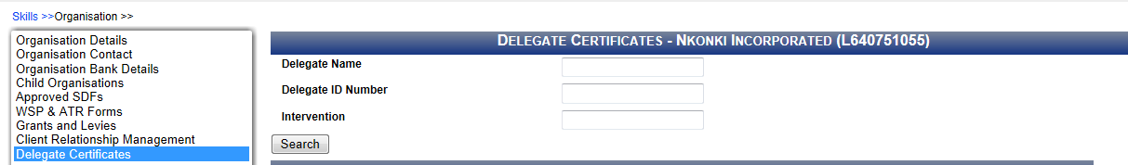

- The display with show all learners who participated and you can select the relevant learners – then generate certificate

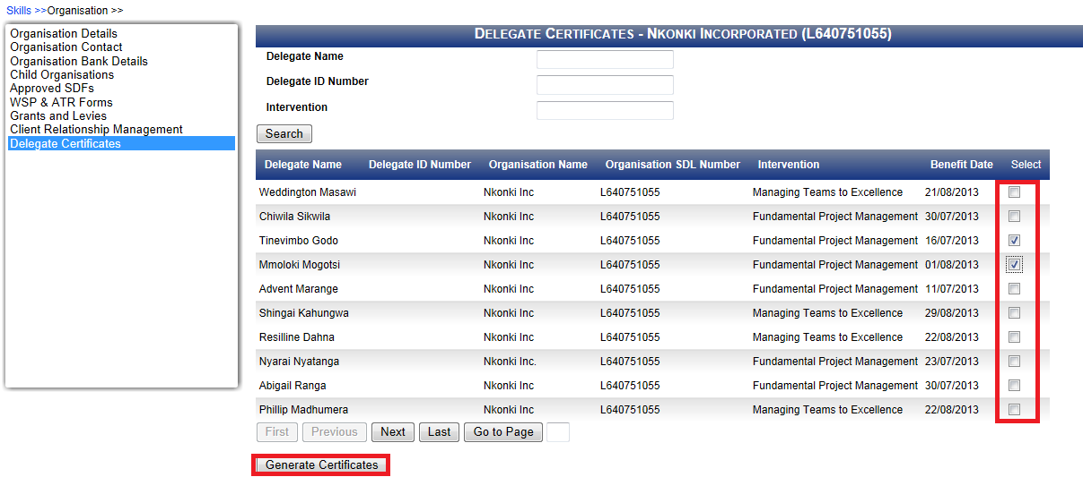

- Then download generated certificate

